***Energy Sources***

***Introduction and applications of Energy sources like***

1. ***Fossil fuels***
2. ***Nuclear fuels***
3. ***Hydel***
4. ***Solar***
5. ***Wind***
6. ***Bio-fuels***

***Environmental issues like Global warming and Ozone depletion***

The energy existing in the earth is known as Capital energy and that comes from outer space is called Celestial Energy. The Capital energy sources are mainly, Fossil fuels, nuclear fuels and heat traps.

**Fossil fuels**

Fossil fuels are energy rich substances that have been formed from long-buried plants and micro­ organisms. Fossil fuels include petroleum, coal and natural gas. Chemically fossil fuels consist largely of hydrocarbons, which are compounds of hydrogen and carbon. Hydrocarbons are formed from ancient living organisms that were buried under layers of sediment millions of years ago. As accumulating sediment layers exerted increasing heat and pressure, the remains of the organisms gradually transformed into hydrocarbons.

Petroleum Formation

Petroleum is formed chiefly from ancient microscopic plants and bacteria that lived in the ocean and saltwater seas. When these micro-organisms died and settled to the seafloor, they mixed with sand and the silt to form organic-rich mud. As layers of sediment accumulated over this organic ooze, the mud was gradually heated and slowly compressed into shale, chemically transforming into petroleum. The petroleum fills the tiny holes within nearby porous rocks. The liquid petroleum and gases which are less dense than water and lighter move upwards through the earth's crust. A portion of this petroleum eventually encounters an impermeable layer of rock which traps the petroleum, creating a reservoir of petroleum and natural gas.

Coal Formation

Coal is a solid fossil fuel formed from ancient plants - including trees, ferns, and mosses - that grew in swamps and bogs or along coastal shore lines. Generations of these plants died and were gradually buried under layers of sediment As the sedimentary overburden increased, the organic material was subjected to increasing heat and pressure that cause the organic material to undergo a number of transitional states to form coal. The mounting pressure and temperature caused the original organic material, which was rich in carbon, hydrogen and oxygen, to become increasingly carbon-rich and hydrogen-and - oxygen-poor. The successive stages of coal formation are peat (partially carbonized plant matter), bituminous coal (soft coal with higher carbon and low moisture), and anthracite {hard coal with highest carbon content and lowest moisture content).

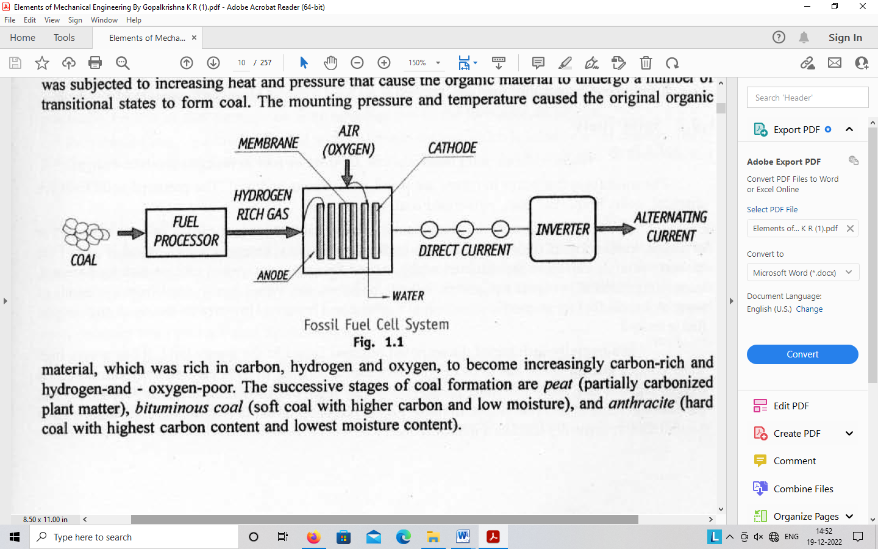

**Nuclear Power**

Nuclear energy is the chemical energy released during the splitting or fusing of atomic nuclei. The atom consists of a small, massive, positively charged core nucleus surrounded by electrons. The nucleus, containing most of the mass of the atom, is itself composed of neutrons and protons bound together by very strong nuclear forces, much greater than the electrical forces that bind the electrons to the nucleus. Protons carry a positive charge. Neutrons carry no electric charge. The binding energy of a nucleus is a measure of how tightly its protons and neutrons arc held together by the nuclear forces.

A nuclear reaction involves changes in the structure of the nucleus. As a result of such changes, the nucleus gains or loses one or more neutrons or protons and release useful amounts of energy. The nuclear energy, measured in millions of electron volts (MeV) is released by the fusion and fission nuclear reactions.

**Fusion Process**

In the fusion process, when light masses of nuclei such as deuterium and tritium-the two forms of hydrogen, are combined with the excess binding energy is released. When two nuclei of deuterium are forced together they momentarily form an unstable nucleus which immediately releases one neutron and become helium or one proton and become tritium. The resulting nucleus has less mass than the two original nuclei - the lost mass gets converted into energy.

A reactor based on deuterium-tritium fusion would release 80 percent of its energy in the very fast moving neutrons. These neutrons could heat a jacket of liquid lithium eventually producing usable electricity from a conventional steam powered generator. Neutrons would also cause fission in some lithium nuclei producing tritium fuel for the basic fusion reaction with deuterium.

**Fission Process**

Nuclear fission involves splitting the nucleus of heavy atoms, like uranium or plutonium in a controlled nuclear chain reaction. During fission heat is released and this can be used to generate high pressure steam to drive turbo-generators and produce electricity.

Most of the nuclear power plants are based on the fission of the nucleus of Uranium-235 atoms. This nucleus is relatively unstable and can split into two or more fragments when struck by a neutron. The splitting or fission yields energy together with an emission of more neutrons. These neutrons in turn can go on to cause further splits in other nuclei producing more energy and more neutrons. This is known as a chain reaction. If there is a sufficient mass or U-235 in suitable geometry we can get a self-sustaining chain reaction which can, therefore lead to continuous generation of energy.

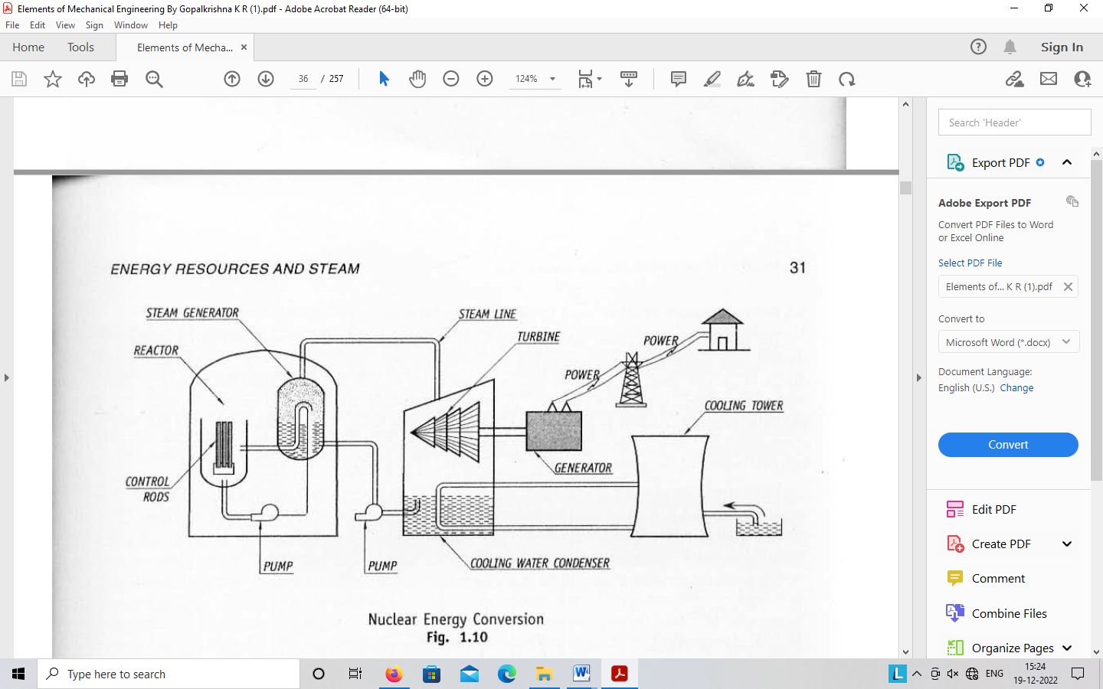

**Hydro Power**

Hydro energy is considered as an indirect source of solar energy. The water from the earth's surface gets evaporated by solar heat and is transported by winds. This in turn results in rainfall. This hydrological cycle is going on since ages. The rain water flowing as river can be stored to higher levels by building dams across the river and released in a controlled way to generate mechanical power. The potential energy of water stored at a height is converted into mechanical energy in water turbines. The mechanical energy produced by the water turbines is further converted into electrical energy by the electric generators which are coupled to the water turbines. A typical hydro-power station is as shown in Figure.The electrical energy generation by hydro-electric power plants is non-polluting and is a renewable source of energy. The several problems associated with the hydro energy are, construction of giant dams alters the ecology of both the upstream and downstream regions, dislocation of living activities, submerging of agricultural lands, etc.

**Pelton wheel**

The Pelton wheel is the most commonly used type of' Impulse turbine. It works under n high head and requires small quantity of water. Figure shows a schematic sketch of a Pelton Wheel. The water from a high head source is supplied to the nozzle provided with a needle, which controls the quantity or water flowing out or the nozzle. The pressure energy of water is converted into velocity energy as it flows through the nozzle. The jet of water issuing out of the nozzle at high velocity impinges on the curved blades known as pelton cups, at the centre as shown in the adjoining figure. The impulsive force of the jet striking on the Pelton cups sets up the pelton wheel to rotate in the direction of the impinging jet. Thus the pressure energy of the water is converted into mechanical energy. The pressure inside the casing of the turbine will be at atmospheric pressure.



Solar Power

Solar radiation is radiant energy emitted by the sun, particularly electromagnetic energy. Energy from the Sun can be tapped and used for various applications like cooking, water heating, lighting, in power plants, and much more.

Solar Power is the power obtained by harnessing the energy given out by Sun's rays.

**Solar Energy Conversion**

Solar energy can be converted into other forms of energy by three primary processes - the

The Heliochemical process, the helioelectrical process and the heliothermal process.

**Heliochemical Process**

The heliochemical process is a photosynthesis process which is the source of all fossil fuels and the food on which we live today. The photosynthesis is a complex biochemical reaction in which the plants using the solar energy synthesise to produce energy rich molecules of starch and cellulose, and oxygen from the inorganic materials like carbon dioxide and water. Thus, photosynthesis is a form of biological conversion of solar energy into chemical energy called bioenergy which will be stored in plants. The overall efficiency of this conversion process from solar energy to stored energy is very low.

**Helioelectrical Process**

In the helioelectrical process, using the principle of photovoltaic effect, the solar energy is directly converted into electrica1 energy. Although the principle of photovoltaic effect was known for over a century, the first solar cell was produced in 1954 at Bell Laboratories in the U.S.A. Till recently; the most significant application of the solar cell was for providing power for space vehicles. Of late, even though the cost of solar cells is highly prohibitive, they are being used for terrestrial low power applications.

A wide variety of materials exhibit the photovoltaic effect. Among the semiconductors, the most commonly used are silicon, germanium, cadmium sulphide, gallium arsenide, etc. The silicon is the one that is generally used because of its higher conversion efficiencies, longer life and low cost.

**Principle of' conversion of Solar Energy into Electrical Energy**

In an ordinary copper wire, the copper atoms have electrons that are free to move from atom to atom. Such a flow of electrons makes up an electric current. ln an ideal state, the semiconductor materials are insulators as they have no free electrons. But if very small amounts of impurities such as antimony, arsenic, or phosphorus are present in semiconductor materials. a few free electrons are produced that can move and form an electric current. When photons from the sun are absorbed by a semiconductor, they create free electrons with higher energies than the electrons which provide the bonding in the base crystal. Once these electrons are created, there must be an electric field to induce these high energy electrons to flow out of the semiconductor.

**Heliothermal Process**

In the heliothermal process, the radiant solar energy falling on the surface placed on the earth in the form of the visible light is converted directly in to thermal energy. The surfaces on which the solar rays fall are called collectors. Basically, two types of collectors are used. In one of the types, known as non-concentrating type, generally called flat plate collector, the incident solar rays are absorbed by the collectors surface itself. In the other type known as concentrating type, generally called as focusing collector, the solar rays fall on a large curved reflecting surface which reflects all the incident rays and focus them to form a highly concentrated narrow beam which will be absorbed later.

The amount of solar radiation incident on a surface is called solar insolation.

**Wind Energy**

Wind energy is defined as the kinetic energy associated with the movement of large masses of air over the earth's surface. The circulation of air in the atmosphere is caused by the non-uniform beating of the earth's surface by the sun.

**Power in the Wind**

Wind possesses kinetic energy by virtue of its motion. Any device capable of slowing down the mass of moving air, like a sail or propeller, can extract part of this energy and convert into useful work.

The kinetic energy of one cubic meter of air blowing at a velocity V is given by,

**E =1/2 ρ V2 J/m3**

The rate at which the wind energy is transferred, i.e., wind power is given by,

*P* = *EV=* ½ ρ *V3 Wlm2*

**The power available in the wind is proportional to the third power of velocity.**



**Introduction to Bio Fuels**

***What are Bio fuels?*** Biofuels are liquid fuels which are derived from biomass or bio waste. Biofuels are produced from sugar crops (sugarcane, sugarbeet), starch crops (com, potatoes), oilseed crops (soybean, sunflower, rapeseed), and animal fats.

**Commonly used types of bio fuels**

1. ***Solid biofuels***are fuels existing from thousands of years and these are biomasses that are burnt directly for energy. Examples include wood, charcoal, dried manure, non-food energy crops, and domestic refuse, sawdust and grass cuttings.
2. ***Biodiesel*** is a domestically produced, renewable fuel that is produced from vegetable oils, animal oils/fats, waste cooking oil, recycled grease, etc. It is a clean-burning replacement for petroleum diesel' fuel and is also non-toxic and biodegradable. These oils are converted to Biodiesel by a process known as ***trans-esterification.*** Biodiesel can be used either as a pure fuel or blended with petroleum in certain percentages.
3. ***Bioethanol or ethanol*** is an alcohol produced by fermentation, majorly from carbohydrates produced in sugar or starch crops like sugarcane, corn or sweet sorghum (a type of grass). Cellulosic biomass, which is derived from non-food sources, like trees and grasses, is also currently being developed as a feedstock for ethanol production.
4. ***Gaseous biofuels*** are biofuels used in the gaseous form. Example if the *biogas,* which is essentially methane gas, produced from biodegradable waste or energy crops. *Syngas* is another example of gaseous biofuel which is basically a mixture of carbon monoxide and hydrogen derived from partial combustion of biomass

**Engineering applications of biofuels**

Bio fuels find their use in various Engineering applications as given below:

1. Biogas is a cheap and sustainable fuel used in lighting, cooking or generating electricity. In India, biogas or gobar gas is produced mainly in rural parts at household level or at large-scale by anaerobic digestion of organic material, usually animal dung, human excreta and crop residue. Biogas is also use as a power source for tractors, pump-sets, etc.
2. Biodiesel finds its use automotive industry mainly in cars and trucks which now come with a flex-fuel option that permits them to run on ethanol/gasoline blends from 0% to 85% ethanol. It has been found that normal gasoline vehicles can operate on a 10% ethanol blend without any issues. Newer Diesel cars and trucks can run on biodiesel, but the older models may need replacement of their fuel lines and gaskets with modem synthetic materials, since biodiesel is a solvent.
3. Small engines, of the kind seen in lawn mowers and chainsaws, can utilize ethanol blends up to 10 percent without problems.
4. Biofuel finds its application in aviation industry and flights are already tested to run with a 20% blend of biofuels in its engine. Various airlines around the World have tested the use of biofuels and the studies and research are in progress on the effect of biofuels on the engine performance.
5. The Marine industry also uses biodiesel in suitable blend mixtures to be used in recreational boats, inland commercial ships, ocean-going commercial ships, research vessels and fleets.
6. Syngas, a gaseous biofuel can be used directly in combustion engines or gas turbines and also can be used to produce methanol and hydrogen or even be converted into diesel substitutes or gasoline.

**Comparison of bio fuels with petroleum fuels**

The Table below offers brief comparison of bio fuels and petroleum fuels

|  |  |  |  |
| --- | --- | --- | --- |
| SL  No. | Factor | Bio Fuels | Petroleum Fuels |
| I. | Calorific  Value | The calorific value of biofuels vary from 30to 37.27 MJ/kg. The variations in the calorific values are mainly due to variability of the feedstock (which is source of triglycerides) | The calorific value of petroleum fuels varies between 43 to 48 MJ/ kg. |
| 2. | Emissions | The Greenhouse gas emissions are less in biofuels. About 17.90 pounds of Carbon dioxide is emitted from the fossil fuel content when a gallon of B20 Biodiesel is burnt.  About 20.13 pounds of Carbon dioxide are produced by burning one gallon of B100 (I 00% biodiesel).  The use of B20 biodiesel reduces Carbon-di-oxide gas emissions by l5%. Recently it has been reported that biofuels derived from algae can cut emissions of Carbon dioxide by 68% compared to the Petroleum fuels. | Greenhouse gas emissions are more in petroleum fuels. Greenhouse gases trap the sun rays inside our atmosphere which causes global warming.  lt is about 19.64 pounds of carbon dioxide that is produced by burning a gallon of gasoline without ethanol. About 22.38 pounds of carbon dioxide are produced by burning a gallon of diesel fuel. |

|  |  |  |  |
| --- | --- | --- | --- |
| Sl.  No. | Factor | Bio Fuels | Petroleum Fuels |
| 3. | Biodegradability | Biodegradable | Not biodegradable |
| 4. | Toxicity | Non-toxic | It is toxic and crude petroleum oil can be carcinogenic (cancer- causing)  When oil or petroleum distillates  are burnt, due to incomplete combustion, Carbon monoxide, methanol and soot are also released. These are toxic and cause serious health issues. |
| 5. | Renewability | It is a Renewable fuel since biofuels are made from organic wastes which are available in plenty. | Non Renewable fuel are limited to oil fields of very few regions in the World. |
| . 6 . | Safety | lt is safe to produce biofuels | It is not safer. For instance to find oil reserves, dangerous drilling and mining activities prove to be unsafe. |

# Environmental issues like Global warming and Ozone depletion

Climate change is concerned with how carbon dioxide, methane, and other greenhouse gases are altering the global climate system. Ozone depletion, on the other hand, involves how certain industrially produced chemicals containing chlorine or bromine are damaging the earth's protective stratospheric ozone layer.

# Ozone depletion and climate change

Ozone depletion and climate change have usually been thought of as environmental issues with little in common other than their global scope. The climate system involves the atmosphere - specifically processes within the troposphere, such as air circulation patterns - land surfaces and oceans. The ozone layer is found in the stratosphere, which is the layer of the atmosphere immediately above the troposphere.

Climate change is concerned with how carbon dioxide, methane, and other greenhouse gases are altering the global climate system. Ozone depletion, on the other hand, involves how certain industrially produced chemicals containing chlorine or bromine are damaging the earth's protective stratospheric ozone layer. However, as the global community has come to understand more about these issues, and the complex physical and chemical processes that drive them, we have become increasingly aware of the ways in which actions to address each are interlinked. The most obvious linkage between efforts to mitigate ozone depletion and climate change is the fact that certain ozone-depleting substances (ODS) such as chlorofluorocarbons (CFCs) and hydrochlorofluorocarbons (HCFCs) are also powerful greenhouse gases.

In addition, hydrofluorocarbons (HFCs) and other halocarbons, which do not deplete the ozone layer but are greenhouse gases, are currently commonly used as alternatives to CFCs and HCFCs. This illustrates the need to consider the implications for both issues when choosing alternatives to ODS, and to consider environmental impact as an important factor, in addition to technical and financial feasibility.

Another important linkage involves the way that ozone-depleting substances and greenhouse gases alter certain processes in the atmosphere so as to enhance both global warming and stratospheric ozone depletion. These changes result in a warming of the troposphere and a cooling of the stratosphere. Stratospheric cooling is a key factor in the development of ozone holes over the poles.

It is clear that actions to mitigate global warming can have positive effects on ozone depletion and vice versa. However, care must be taken to avoid solutions to one problem that make the other worse.

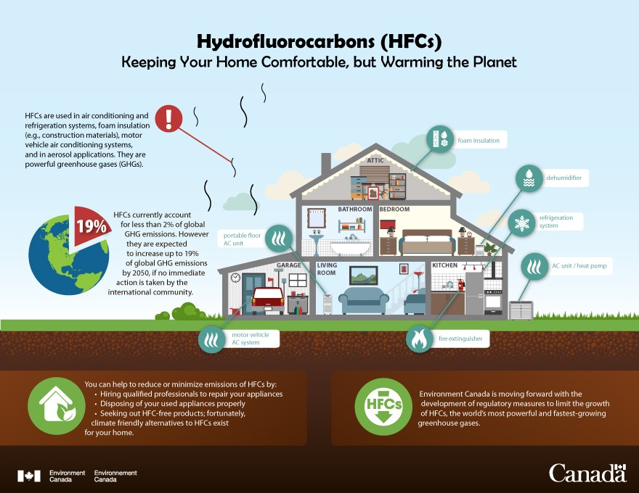

## Human activities cause ozone depletion and global warming

Ozone (O3) depletion does not cause global warming, but both of these environmental problems have a common cause: **human activities that release pollutants into the atmosphere altering it.**

Global warming is caused primarily by putting too much carbon dioxide into the atmosphere when coal, oil, and natural gas are burned to generate electricity or to run our cars.

Carbon dioxide spreads around the planet like a blanket, and is one of the main gases responsible for the absorption of infrared radiation (felt as heat), which comprises the bulk of solar energy.

Ozone depletion occurs when chlorofluorocarbons (CFCs) and halons—gases formerly found in aerosol spray cans and refrigerants—are released into the atmosphere (see details below).

Ozone sits in the upper atmosphere and absorbs ultraviolet radiaton, another type of solar energy that's harmful to humans, animals and plants. CFCs and halons cause chemical reactions that break down ozone molecules, reducing ozone's ultraviolet radiation-absorbing capacity.

## How ozone works

The sun emits electromagnetic radiation at different wavelengths, meaning energy at different intensities. The atmosphere acts like a multi-layer shield that protects Earth from dangerous solar radiation.

Ozone is found in two different parts of our atmosphere. Ground level or “bad” ozone is a human health irritant and component of smog. It is found in the lower atmosphere (troposphere) and has nothing to do with the "ozone hole."

High level or “good” ozone occurs in the stratosphere and accounts for the vast majority of atmospheric ozone.

The stratospheric ozone layer absorbs ultraviolet (UV) radiation, preventing dangerous UV rays from hitting Earth's surface and harming living organisms. UV rays cannot be seen or felt, but they are very powerful and change the chemical structure of molecules.

UV radiation plays a small role in global warming because its quantity is not enough to cause the excess heat trapped in the atmosphere. UV radiation represents [a small percentage](https://www.ucar.edu/learn/1_3_1.htm) of the energy from the sun, and is not highly absorbed or scattered in the atmosphere—especially when compared with other wavelengths, like infrared. But, ozone depletion is also concerning because it directly impacts the health of humans, and other living organisms.

## The ozone hole

The term ‘ozone hole’ refers to the depletion of the protective ozone layer in the upper atmosphere (stratosphere) over Earth's polar regions. People, plants, and animals living under the ozone hole are harmed by the solar radiation now reaching the Earth's surface—where it causes health problems, from [eye damage](https://www.ncbi.nlm.nih.gov/pmc/articles/PMC1298891/) to [skin cancer](http://pubs.rsc.org/en/content/articlelanding/2011/pp/c0pp90044c#!divAbstract).

Stratospheric ozone is constantly produced by the action of the sun's ultraviolet radiation on oxygen molecules (known as photochemical reactions). Although ozone is created primarily at tropical latitudes, large-scale air circulation patterns in the lower stratosphere move ozone toward the poles, where its concentration builds up.

In addition to this global motion, strong winter [polar vortices](http://www.nws.noaa.gov/om/cold/polar_vortex.shtml) are also important to concentrating ozone at the poles. During the continuously dark polar winter, the air inside the polar vortices becomes extremely cold, a necessary condition for polar stratospheric cloud formation.

[Polar stratospheric clouds](https://www.nasa.gov/multimedia/imagegallery/image_feature_680.html) create the conditions for drastic ozone destruction, providing a surface for chlorine to change into ozone-destroying form. They generally last until the sun comes up in the spring.

In the 1980s, scientists discovered that [the ozone layer](https://www.epa.gov/ozone-layer-protection/basic-ozone-layer-science) was thinning in the lower stratosphere, with particularly dramatic ozone loss—known as the "ozone hole"—in the Antarctic spring (September and October).

Scientists also discovered that the thinning in the ozone layer was caused by [increasing concentrations of ozone-depleting chemicals](https://www.epa.gov/ozone-layer-protection/basic-ozone-layer-science) – chlorofluorocarbons or CFCs (compounds with chlorine and/or fluorine attached to carbon) and to a lesser extent halons (similar compounds with bromine or iodine). These chemicals can remain in the atmosphere for decades to over a century.

At the poles, CFCs attach to ice particles in clouds. When the sun comes out again in the polar spring, the ice particles melt, releasing the ozone-depleting molecules from the ice particle surfaces.

Once released, these ozone-destroying molecules do their dirty work, breaking apart the molecular bonds in UV radiation-absorbing ozone.